Class distribution + file-type breakdown
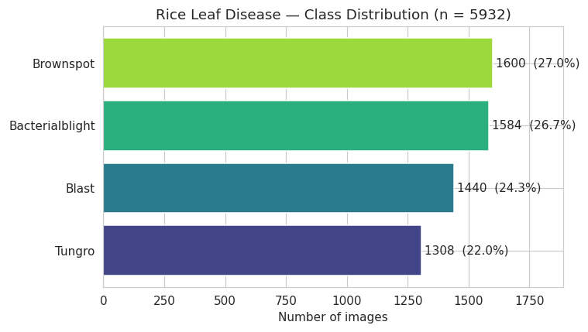

Total images: 5932
Number of classes: 4
Classes: ['Bacterialblight', 'Blast', 'Brownspot', 'Tungro']

Class distribution:

count percent
label
Brownspot 1600 27.0
Bacterialblight 1584 26.7
Blast 1440 24.3
Tungro 1308 22.0

Largest class : Brownspot (1600)
Smallest class: Tungro (1308)
Imbalance ratio (max/min): 1.22 : 1

File extensions:
ext
.jpg 5932

The largest class (Brownspot, 1600) is only 1.22× the smallest (Tungro, 1308). That ratio is the imbalance ratio, and 1.22:1 is essentially balanced — for comparison, a "problem" dataset is more like 5:1 or 10:1. This means you won't need aggressive class-weighting or oversampling; plain accuracy will be a meaningful metric here, not a misleading one.

This dataset ships as raw class folders with no train/val/test division

Sample image grid (one row per class)
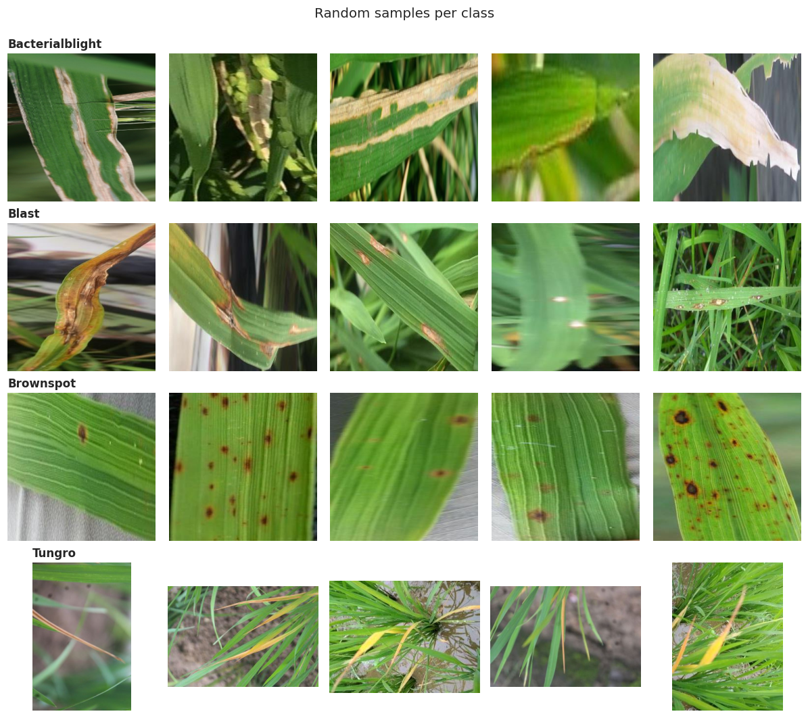
What each disease looks like (and whether the labels are trustworthy):
Class | What I see | Distinctness
Bacterialblight | Elongated straw/tan lesions running along leaf margins and blades, some fully whitened/dried tattered leaves. Tight leaf close-ups. | Distinct ✓
Blast | Spindle / eye-shaped lesions with brown borders, plus tip dieback (browning from the tip inward). Leaf close-ups. | Mostly distinct ✓
Brownspot | Scattered discrete brown circular/oval spots, some with yellow halos. Textbook. Leaf close-ups. | Very distinct ✓
Tungro | Yellow-orange discoloration on whole plants / clumps, shot zoomed-out against bare soil. | Distinct — but for the wrong reason ⚠️

The trap: Tungro has a systematically different background and framing. Look at the difference — Bacterialblight, Blast, and Brownspot are all tight close-ups of individual leaves against green or blurred foliage. Tungro is the odd one out: zoomed-out shots of entire plants against brown soil/dirt.
This is a textbook background-bias / spurious-correlation problem, and it's exactly the "lab-to-field gap" issue our project summary flags. Here's why it's dangerous: a CNN doesn't know you want it to look at the leaf. If "brown soil background" perfectly predicts "Tungro" in the training data, the model will happily learn that shortcut instead of the actual viral yellowing symptoms. we'd then see a beautiful 97%+ validation accuracy that collapses the moment a real farmer photographs a Tungro-infected plant against a green background — or worse, the model labels any soil-background photo as Tungro. This is precisely the kind of silent failure that makes a disease detector useless in the field.
it means:
- When we split, the Tungro shortcut will hide the problem (train and val both have soil backgrounds), so we must test robustness explicitly later.
- Segmentation or aggressive background augmentation (the interventions in our summary — UNet masking, background randomization) move from "nice to have" to "probably necessary" for Tungro specifically.
- It's worth eventually checking whether Tungro's image dimensions also differ systematically — which is exactly what the next details measures.

Image dimensions, aspect ratio & color mode (overall + per class
Color modes:
mode
RGB 5776
RGBA 156

Overall dimension summary:
width height aspect megapixels
count 5932.00 5932.00 5932.00 5932.00
mean 312.24 312.20 1.02 0.10
std 53.42 53.45 0.18 0.03
min 209.00 209.00 0.66 0.06
25% 300.00 300.00 1.00 0.09
50% 300.00 300.00 1.00 0.09
75% 300.00 300.00 1.00 0.09
max 603.00 603.00 1.51 0.24

Most common (width, height) pairs:
300 x 300 -> 4624 images (78.0%)
295 x 221 -> 12 images (0.2%)
499 x 332 -> 12 images (0.2%)
221 x 295 -> 12 images (0.2%)
521 x 348 -> 11 images (0.2%)
288 x 216 -> 11 images (0.2%)
284 x 426 -> 10 images (0.2%)
331 x 497 -> 10 images (0.2%)

Median dimensions per class:
width height aspect megapixels
label
Bacterialblight 300.0 300.0 1.00 0.09
Blast 300.0 300.0 1.00 0.09
Brownspot 300.0 300.0 1.00 0.09
Tungro 331.0 331.0 1.33 0.12

Now the striking part — the dimension fingerprint. Look at these two facts together:
- 78.0% of images are exactly 300×300 (4,624 of them). The author pre-resized to a fixed square.
- 4,624 is exactly Bacterialblight + Blast + Brownspot (1584 + 1440 + 1600 = 4624).

So Tungro wasn't just photographed differently (zoomed-out, soil background — what we saw in Cell 4) — it was also processed through a completely different pipeline. The other three classes were squished to 300×300 squares; Tungro kept its native ~4:3 camera dimensions (1.33 is the classic 4:3 ratio).

Why this matters for our model: we now have three independent signals that all separate Tungro from the rest — background (soil), framing (whole-plant), and dimensions (non-square, non-300). After we resize everything to a common size for training, the dimension signal disappears, but the background and framing shortcuts remain. This is the strongest possible evidence that Tungro is where our model will cheat if we let it, and where we must test robustness hardest.

Resolve the RGBA format mystery + per-class dimension fingerprint
RGBA images by class:
label
Bacterialblight 108
Brownspot 48

True encoded format of the RGBA files (despite the .jpg name):
PNG: 156

300x300 images per class:
is_300x300 total pct_300x300
label
Bacterialblight 1584 1584 100.0
Blast 1440 1440 100.0
Brownspot 1600 1600 100.0
Tungro 0 1308 0.0
All 156 "problem" files came back as PNG — confirmed. They're named .jpg but are PNG-encoded internally, which is why they carry an alpha channel. They sit in Bacterialblight (108) and Brownspot (48), none in Blast or Tungro. This is now fully understood and fully handled: .convert("RGB") in your loader flattens them.

The dimension fingerprint is now black-and-white:
- Bacterialblight, Blast, Brownspot → 100.0% exactly 300×300.
- Tungro → 0.0% at 300×300.
What this means concretely when we get to modeling — three defenses, in order of importance:
- Resize everything to one common size (e.g., 224×224) at load time. This kills the dimension shortcut outright — after this step, 300×300 and 331×331 both become 224×224, so the model can't use size to cheat.
- Background augmentation (random crops, background swaps, or segmentation masking) to attack the soil-background and framing shortcuts — the two that survive resizing.
- A deliberate robustness test: hold out (or hand-collect) a few Tungro images on green backgrounds and non-Tungro images on soil backgrounds, and check the model doesn't flip. If accuracy holds there, we've beaten the shortcut.

Exact + near-duplicate detection (perceptual hashing)

Exact (byte-identical) duplicate files: 2234
...forming 1096 groups of identical images
exact-dup groups spanning >1 class (label conflicts): 0

Near-duplicate groups (identical 8x8 perceptual hash): 1724
Images involved in a near-dup group: 4914 (82.8%)
within-class near-dup groups : 1724
cross-class near-dup groups : 0 (these are label-noise red flags)

Near-duplicate images per class:
label
Brownspot 1540
Bacterialblight 1509
Blast 1432
Tungro 433

We got 38% byte-identical and 82.8% near-duplicate. That's not normal — it reframes this from "a clean dataset" to "clean labels, but heavily redundant."
What's genuinely reassuring (labels are sound):
- 0 exact-dup groups span >1 class and 0 cross-class near-dup groups. No file appears under two different disease labels. labels are internally consistent — there's no label-noise contradiction. That's the failure mode that would cap our accuracy, and it's absent. Good.
The exact duplicates (unambiguous, byte-level):
- 2,234 files are byte-for-byte identical, forming 1,096 groups. Keeping one copy per group removes 1,138 redundant files, leaving roughly 4,794 truly unique files out of 5,932. So ~19% of dataset is literal copies.
The near-duplicate 82.8% — real signal, but read it with one caveat. An 8×8 aHash is a coarse fingerprint: it shrinks each image to 64 bits, so it can occasionally merge genuinely-different-but-similarly-composed leaves. So I don't want to hand you "82.8%" as gospel until we re-check with a stricter hash. That said, it's corroborated by the hard 38% exact-dup rate, so the direction is certainly real: this dataset has heavy internal redundancy.
The per-class pattern is the tell. Near-dup share by class: Blast ~99%, Brownspot ~96%, Bacterialblight ~95%, but Tungro only ~33%. That's the same split we keep seeing — the three 300×300 classes behave one way, Tungro another. It suggests the three standard classes were padded/expanded much more aggressively than Tungro. Which means after deduplication true class balance may look quite different from the 1.22:1 .
Why this is the highest-stakes finding for your project: with 83% of images sitting in near-dup groups, a naive random 80/20 split will scatter near-identical images across both train and test. The model then sees test images (or near-copies) during training, and we get a gorgeous, completely fake accuracy. This is exactly the "faithfulness vs. fluency" integrity concern from our project summary, but at the data level. The fix is a group-aware split: cluster by hash, then assign whole clusters entirely to train or test, never both.
Before we design that, two things to nail down: the true deduplicated class balance, and a stricter near-dup recount so we know how much to trust the 82.8%.

True unique-image accounting + stricter (pHash) near-dup recount

The near-dup rate holds up. pHash (the stricter, DCT-based hash) came back at 79.2%, barely below aHash's 82.8%. I'd floated the possibility that aHash was over-merging and the real number might be 30–40% — it wasn't. Two independent hashing methods agreeing at ~80% means the redundancy is real, not an artifact. And pHash also found 0 cross-class near-dup groups, independently re-confirming your labels are clean. So the redundancy is severe, but the labeling is trustworthy — that combination is the whole story of this dataset.
Look at how unevenly the duplication is distributed:
Class | Raw | Unique | % redundant
Tungro | 1308 | 1308 | 0.0%
Bacterialblight | 1584 | 1326 | 16.3%
Brownspot | 1600 | 1200 | 25.0%
Blast | 1440 | 960 | 33.3%
Tungro has zero exact duplicates while Blast is one-third padding. Strip the copies and the ordering flips: Bacterialblight becomes the largest real class (1326) and Blast the smallest (960), at a 1.38:1 true ratio. Still manageable, but the takeaway is bigger than the number: the "balance" was partly manufactured by duplication

What this locks in for modeling:
- our real training pool is ~4,794 unique images, not 5,932 — and after near-dup grouping, the count of truly independent images is lower still (~80% sit in near-dup clusters).
- The split must be group-aware (cluster by pHash → assign whole clusters to one side). A random split would leak, and given 79% near-dup membership, it would leak massively — inflating test accuracy by what could easily be 10–20 points of pure fiction.
- Deduplicate before we compute class weights, or we'll weight toward Blast's copies.
EDA summary dashboard + export deduplicated manifest
